IDC1-42 Series

Integrated pulse-type open-loop

stepper driver

User Manual V1.0.0

Table of contents
one,Product Introduction - 1 -
1.1 Product Overview - 1 -
1.2 Product Features - 1 -
1.3 Application Areas - 1 -
1.4 Naming Rules - 2 -
two,Electrical, mechanical and environmental specifications - 3 -
2.1 Mechanical Installation Drawing - 3 -
2.2 Installation Notes - 3 -
2.3 Electrical specifications - 3 -
2.4 Operating environment and parameters - 4 -
three,Driver interface and wiring introduction - 4 -
3.1 Interface Diagram - 4 -
3.2 Interface Description - 4 -
3.2.1 Power Input Interface - 4 -
3.2.2 Control signal interface - 5 -
3.2.3 Call the policeStatus Indicator - 5 -
3.3 Input Control Signal - 5 -
3.3.1 Input control signal interface circuit - 5 -
3.3.2 Control signal timing diagram - 6 -
3.4Wiring requirements - 6 -
Four,DIP Definition - 7 -
4.1 Current setting - 7 -
4.2 Segmentation Settings - 7 -
five,Power supply selection - 7 -
six,Adaptive motor parameters and selection - 8 -
6.1 Schematic diagram of the motor appearance - 8 -
6.2 Motor technical parameters - 8 -
6.3 Motor shaft parameters - 8 -
seven,Warranty and after-sales - 9 -
7.1 Warranty - 9 -
7.1.1 Free warranty - 9 -
7.1.2 Warranty Exclusions - 9 -
7.2 Exchange - 9 -
7.2.1 Replacement of defective product - 9 -
7.2.2 Exchange for non-product failure - 10 -
7.3 Returns - 10 -
7.4 After-sales service - 10 -
eight,Version Revision History - 11 -

Product Introduction

1.1 Product Overview
IDC1-42 integrated pulse open-loop stepper driverIt is the latest one launchedeconomyThe integrated motor driver adopts the latest dedicated motor control digital signal processor to improve the overall performance of the motor, reduce the heat generation and vibration of the motor. The integrated design of motor and driver makes the installation more compact and reduces external interference.

1.2 Product Features
●Integrated motor and drive, saving wiringandArtificial
●Small size, easy to install
●New generation 32-bitARMTechnology, good stability, strong compatibility, high cost performance
Optically isolated differential signal input
●Built-in micro-segmentation, excellent low-speed stability
●The impulse response frequency can reach up to90KHz (higher can be changed)
●Subdivision setting range 200-3600
●Precise current control greatly reduces motor heating
●Low vibration and low noise
●With overvoltage, undervoltage and alarm protection functions
Input voltage range:DC12V~30V
●The default effective current is 1.0A and 1.5A are optional

1.3 Application Areas
Suitable for various small and medium-sized automation equipment and instruments, such as medical equipment, testing equipment, marking machines, plotters, etc. It meets customers' requirements for low noise, low heat generation, convenient wiring, and stronger anti-interference performance.

1.4 Naming Rules
The driver model naming rules are as follows:
I DC1-42M---
① ② ③ ④ ⑤ ⑥ ⑦ ⑧ ⑨

Serial number | meaning
① | 2-phase/3-phase distinction; Empty: 2-phase drive;
② | General term for product series; I: integrated drive;
③ | Product series number; DC1:Economicalpulseopenring;
④ | Matching motor base; 42: Main match42Motor of the base;
⑤ | Integrated bus series open and closed loop distinction;
⑥ | Whether it has a motor; M: with a motor integrated;
⑦ | Motor body length;
⑧ | Special function code;
⑨ | Design change code;

Electrical, mechanical and environmental specifications

2.1 Mechanical Installation Drawing
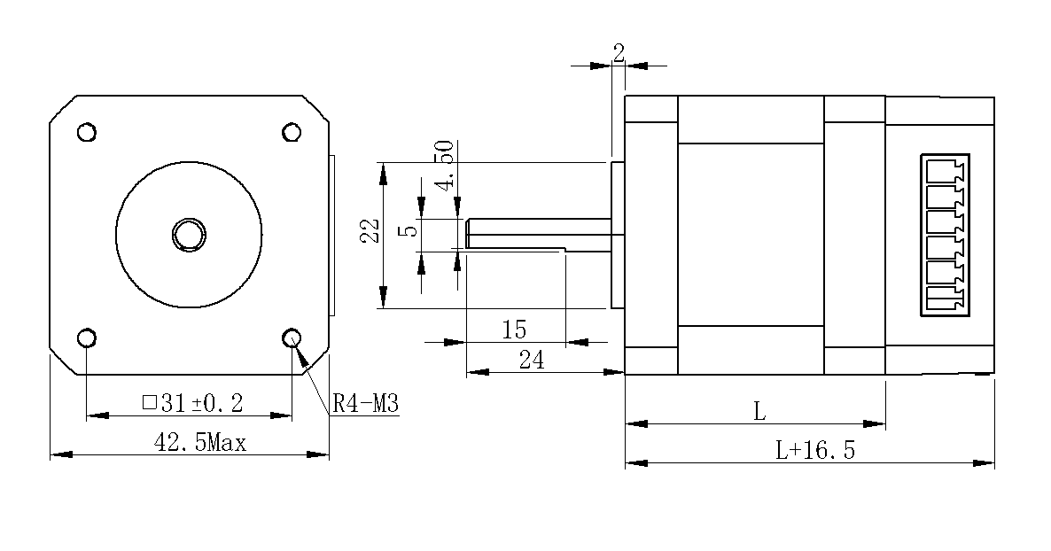
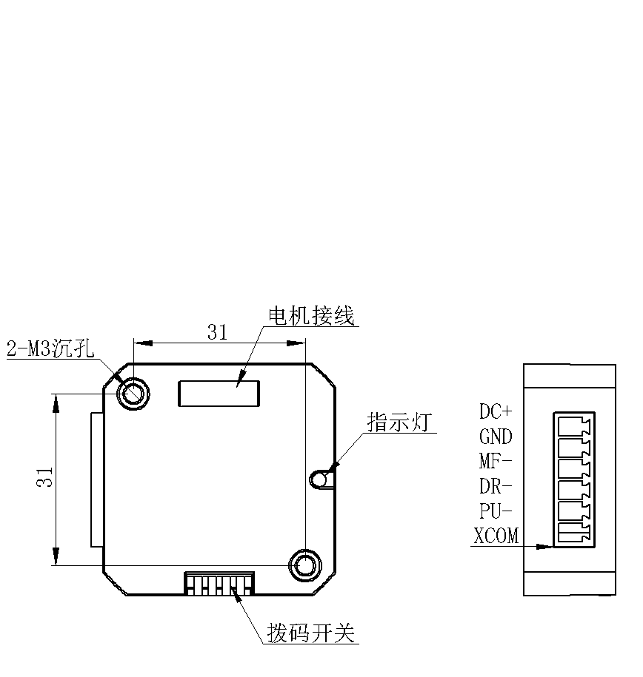
Figure 2.1 Installation dimensions (unit: mm)

2.2 Installation Notes
- When installing the integrated stepper driver, do not knock on the rear end cover of the motor to avoid affecting the operating performance. When designing the installation dimensions, consider the size and wiring of the terminal blocks.
- To ensure good heat dissipation conditions, the actual installation must reserve as large an installation spacing as possible. If multiple integrated drives are installed side by side, fans can be installed to create strong air convection on the surface of the integrated drives to assist in heat dissipation and ensure that the drives operate within a reliable operating temperature range.

2.3 Electrical specifications
illustrate | IDC1-42
illustrate | Minimum | Typical values | Maximum | unit
Input power voltage | 12 | twenty four | 30 | VDC
Control signal input current | 7 | 10 | 16 | mA
Step pulse frequency | 0 | - | 90 | KHz
Insulation resistance | 50 |  |  | MΩ

2.4 Operating environment and parameters
Cooling method |  | Natural cooling, fan cooling
Usage Environment | occasion | Do not place it near other heating equipment. Avoid dust, oil mist, corrosive gas, high humidity and strong vibration. Flammable gas and conductive dust are prohibited.
Usage Environment | temperature | 0-50℃
Usage Environment | humidity | 40-90%RH
Usage Environment | vibration | 10~55Hz/0.15mm
Storage temperature |  | -20℃~65℃

Driver interface and wiring introduction

3.1 Interface Diagram
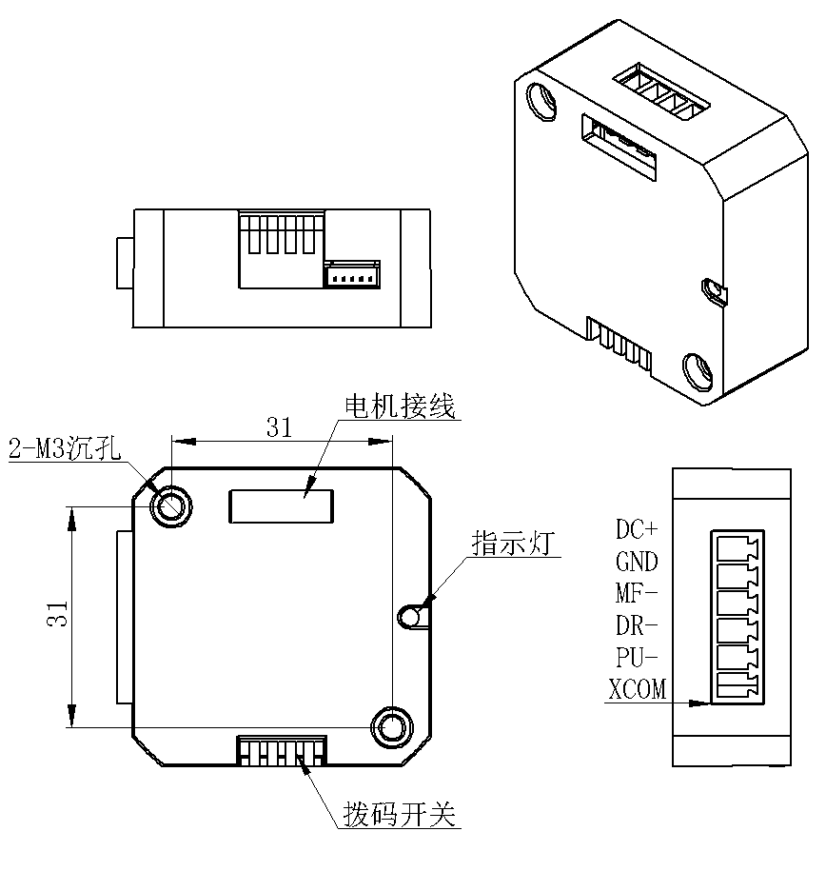
Figure 3.1IDC1-42Interface Diagram

3.2 Interface Description
IDC1-42 integrated pulse open-loop stepper driverThe power interface and signal control interface adopt3.81-6PPlug-in terminal blocksThe specific definition of the interface is described in the following sections.

3.2.1 Power Input Interface
name |  | illustrate | Function
VDC | DC+ | Power interface | Power input  DC12V~30V
VDC | GND | Power interface | Power input  DC12V~30V

3.2.2 Control signal interface
name | Function
PU- | Pulse control signalNegative terminal, the rising edge is valid, and each time the pulse changes from low to high, the motor takes a microstep. In order to reliably respond to the pulse signal, the pulse width should be greater than 2.5μs.
DR- | Direction control signalNegative terminal, high/low level signal. To ensure reliable commutation of the motor, the direction signal should be established at least 50μs before the pulse signal.
MF- | Enable control signalNegative terminal, high/low level signal. Used to enable or disable the motor. When this function is not required, the enable signal terminal can be left floating.
XCOM | Input signal common interface:+5VIf you need a 24V input signal, please contact our technical staff.

3.2.3 Call the policeStatus Indicator
IDC1-42 integrated pulse open-loop stepper driverThe indicator light is a retracted SMD LED, and its basic definition is shown in the following table.
name | Function | illustrate
Green LED | power supply,  Alarm indicator light | When power is on normally,The green light is always on.  driveAn exception occurred(Overvoltage and Undervoltage)When the green light flashes, the alarm.

3.3 Input Control Signal

3.3.1 Input control signal interface circuit
IDC1-42The driver control signal terminal uses a differential interface circuit, which is suitable for differential signals, single-ended common cathode, and common anode interfaces. It has a built-in high-speed optocoupler and strong anti-interference capabilities in harsh environments. The interface circuit diagram is shown in Figure 3.2.
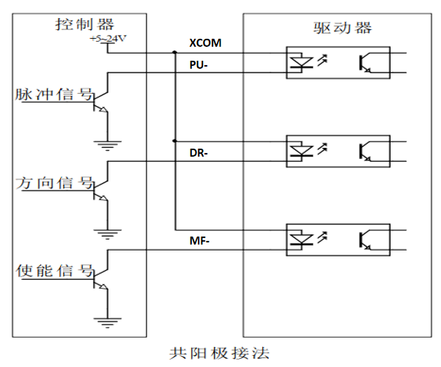
Figure 3.2 Input interface circuit

3.3.2 Control signal timing diagram
In order to avoid some malfunctions and deviations, PU, ​​DR and EN/MFCertain requirements should be met, as shown in the following figure:
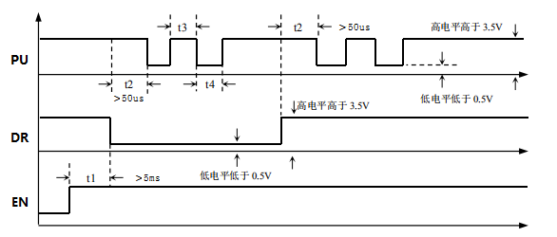
Figure 3.3 Control signal timing diagram
Notes:
- t1:EN/MF(Enable signal) should be at least 5ms ahead of DR and confirmed to be high. Generally, it is recommended to/MF+ and EN/MF-Just leave it hanging.
- t2: DR determines its state as high or low at least 50μs in advance of the falling edge of PU.
- t3: The pulse width must be at least 2.5μs.
- t4: Low level width is not less than 2.5μs.

3.4Wiring requirements
- To prevent interference with the driver, we recommend using shielded cables for control signals, with the shield short-circuited to the ground wire. Unless otherwise specified, the shield of the control signal cable should be grounded at one end: the host computer end of the shield should be grounded, while the driver end should be left floating. Grounding is only permitted at the same point within a machine. If the grounding is not a true ground, interference may be severe, so the shield should be left unconnected.
- The pulse and direction signal lines are not allowed to be wrapped side by side with the motor lines. It is best to separate them by at least 10 cm. Otherwise, the motor noise will easily interfere with the pulse and direction signals, causing inaccurate motor positioning, system instability and other faults.
- If one power supply supplies multiple drives, they should be connected in parallel at the power supply. Chain connection from one drive to another is not allowed.
- It is strictly forbidden to plug or unplug the high-voltage terminals of the driver while it is powered on. When the motor is stopped, there is still a large current flowing through the coil. Plugging or unplugging the terminals while it is powered on will cause a huge instantaneous induced electromotive force that will burn out the driver.
- It is strictly forbidden to connect the wire end to the terminal after adding tin, otherwise the contact resistance may increase and overheat and damage the terminal.
- The wiring ends must not be exposed outside the terminals to prevent accidental short circuit and damage to the driver.

DIP Definition
The IDC1-42 driver uses a 4-position dip switch, SW1 is used to set the current; SW2-SW4 are used for subdivision settings. Detailed description is as follows
SW1 | SW2 | SW3 | SW4
Current setting | Segmentation Settings

4.1 Current setting
When SW1 is off, the effective current value is 1.0A; when SW1 is on, the effective current value is 1.5A.

4.2 Segmentation Settings
pul/rev | SW2 | SW3 | SW4
200 | on | on | on
400 | off | on | on
800 | on | off | on
1600 | off | off | on
3200 | on | on | off
1000 | off | on | off
2000 | on | off | off
3600 | off | off | off

Power supply selection
The power supply voltage can work normally within the specified range.IDC1-42The driver is best powered by a regulated DC switching power supply. Note that the output current range of the switching power supply must be set to its maximum. An unregulated DC power supply can also be used, but ensure that the peak voltage ripple after rectification does not exceed the specified maximum voltage. It is recommended that users use a DC power supply voltage lower than the maximum voltage to prevent grid fluctuations from exceeding the driver's operating voltage range.
▶Note:
- When wiring, be careful not to connect the positive and negative poles of the power supply in reverse;
- When wiring, pay attention to the position of the power interface and do not connect it to the motor port. After connecting, it is best to confirm whether it is connected correctly.
- It is best to use a regulated DC switching power supply;
- When using an unregulated DC power supply, the power supply current output capacity should be greater than 60% of the driver's set current;
- When using a regulated DC switching power supply, the output current of the power supply should be greater than or equal to the operating current of the driver;
- To reduce costs, two or three drivers can share one power supply, but the power supply must be large enough.

Adaptive motor parameters and selection

6.1 Schematic diagram of the motor appearance
Figure 6.1IDC1-42Schematic diagram of the appearance of the series all-in-one machine

6.2 Motor technical parameters
model | Keep  Torque (N.M) | Phase current  (A) | resistance  (Ω) | inductance  (MH) | Rotation  Inertia (g.cm2) | motor  Length L1  (mm) | tail cover  length  (mm) | weight  (Kg) | Number of lines
IDC1-42M-40 | 0.45 | 2.0 | 0.92 | 1.9 | 57 | 40Max. | 16.5 | 0.12 | 4
IDC1-42M-48 | 0.52 | 2.0 | 1 | 1.9 | 76 | 48Max. | 16.5 | 0.17 | 4
IDC1-42M-60 | 0.84 | 2.0 | 1.37 | 3.7 | 128 | 60Max. | 16.5 | 0.21 | 4

6.3 Motor shaft parameters
model | Shaft diameter (mm) | Shaft extension (mm) | Flat position(mm) | Boss (mm)
IDC1-42M-40 | 5.0 | twenty four | 4.5*15 | 2*22
IDC1-42M-48 | 5.0 | twenty four | 4.5*15 | 2*22
IDC1-42M-60 | 5.0 | twenty four | 4.5*15 | 2*22

Warranty and after-sales

7.1 Warranty

7.1.1 Free warranty
Our company solemnly promises that all our products will be repaired free of charge for one year if they are damaged during use. The shipping costs will be borne by both parties.

7.1.2 Warranty Exclusions
- The driver is damaged due to the customer's own wiring errors;
- The driver is damaged due to exceeding the rated working voltage;
- The DC power supply driver is connected to the AC power supply, causing damage to the driver;
- The driver is damaged due to the customer's on-site environment being extremely harsh, such as humidity, extreme cold, extreme heat, etc., without informing our company in advance;
- The customer has dismantled the drive casing without authorization or the serial number label has been torn off;
- 15 days after the customer confirms receipt, the casing is obviously damaged or impacted, resulting in damage to the drive;
- Force majeure natural disasters, such as fire, earthquake, tsunami, typhoon, etc.;
In the above cases, our company will charge a certain amount of repair cost after evaluating the interests of all parties. In other cases, the repair will be free of charge forever.

7.2 Exchange

7.2.1 Replacement of defective product
For any faults that occur in new products, our company provides a three-month free replacement service.
Once our technical support staff confirms that the problem is with the product itself, they will ship the product back to us to avoid wasting time and postage. Customers must first return the faulty product by courier or logistics. Upon receipt, we will promptly ship a replacement product to the customer.
Notice:All our products undergo rigorous testing and aging before leaving the warehouse, so it is extremely rare for new products to malfunction. Please be sure to read the instructions carefully or consult our technical support staff when operating, or our technical support staff will assist customers remotely with the operation.
- Please note the following points when exchanging goods:
- Please ensure that the packaging is complete when sending it back to avoid damage during transportation;
- Please ensure that the included accessories are complete when exchanging;
- Each driver should be packaged independently in its original outer box to avoid secondary damage to the product during transportation;
- If the driver is returned and it is confirmed that the fault is not due to product failure, but rather due to the customer's negligence, who mistakenly believed that the driver was faulty, our company will not bear the shipping costs (customer negligence includes: incorrect wiring resulting in damage to the driver, poor wiring resulting in the driver being mistakenly believed to be damaged, operating errors resulting in the driver not being able to function properly, etc.).

7.2.2 Exchange for non-product failure
If you are dissatisfied with the appearance or functionality of the product you received and would like to exchange it for a superior driver, you can request a replacement within one week of receiving the product. After verification, we will return the product and, upon confirmation that the returned product is undamaged, has all accessories, and is well packaged, we will replace it with another product. If there is a price difference between the replacement product and the replacement product, the customer will pay the difference.
Note: The replaced product will no longer be eligible for the non-product fault replacement service. The round-trip shipping costs and other expenses incurred by the non-product fault replacement service are borne by the customer!

7.3 Returns
Our company provides a 7-day return service for products with quality problems. If you find any quality problems with the product itself within 7 days of receiving the product (based on the actual date of receipt by the customer), please communicate with our salesperson or technical support personnel in a timely manner. After our technical support personnel confirms that it is a quality problem with the company's product itself, the customer can send the original complete product and its inner and outer packaging, accessories and shipping order back to our company by express delivery or logistics.
If the customer still insists on returning the goods after our company has checked and confirmed that they are correct, the round-trip shipping costs and all other expenses incurred shall be borne by the customer.
- Please note the following points when returning products:
(1) Please contact the relevant department of our company before making a refund;
(2) The product must be in new condition and intact packaging. Please send it back to our company by express or logistics;
(3) We will not accept any complaints caused by customers, such as product appearance damage, incomplete accessories, etc.

7.4 After-sales service
If you need after-sales service support when using this product, please contact our company as soon as possible.
National free service hotline: 0755-23206995;
Technical specialist service hotline: 18576758897 (Mr. Xie), 17666115681 (Mr. Tuo);
Service hours: Monday to Friday 8:30-17:30 (except national holidays).

Version Revision History
Version number | illustrate | Modification deadline | Preparer/Reviewer
V1.0.0 | Initial use version; | 2025.02.15 | HY/TCJ

